Energy Work and Birth Workers
Energy work –
- Shifting the energy from negative to positive.
- Protecting your space, so you can stay clear to best serve your clients.
- Clearing old emotions to allow an open path to create new positive experiences.

Basic Tools
Grounding – Sample Script
Close your eyes and imagine you are in a place in nature that feels peaceful and safe to you. Imagine reaching up to the Sun asking for help and support.. your arms reach up, up and up. Then you feel that healing warm light shining down on to you, filled with love, support and peace. The light fills your head and moves down your neck, back, arms, pelvis, legs and down through your feet. Pushing out all the things that are not serving you down through your feet and into the ground. The warmth and light fills you with light, warmth and peace. Down from your feet go roots deep, deep, deep into the earth. Grounding you to the earth and they go so far down they reach the core of the earth and wrap around the core. Then up from the ground comes all you need from the earth, minerals, vitamins, strength and courage. Up, up, up into your body. Feel your body being fully supported by the earth and feel your spirit being fully supported by the light shining down on you. Take a deep breath and when you are ready open your eyes.

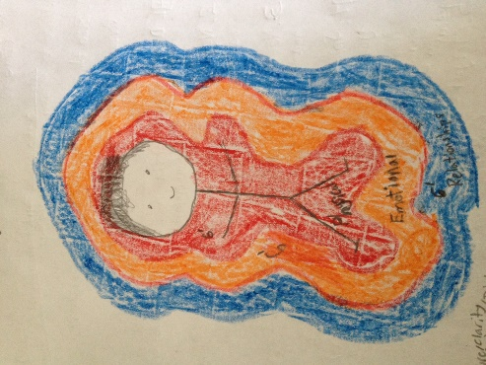
Color Shield – Layers of Colors around your body offer protection for different things. http://sheridanripley.com/create-your-rainbow-shield/

- Red – Physical
- Orange – Emotional
- Blue – Relational
- White – Spiritual
More information Boundaries – Energetic Boundaries by Cyndi Dale

Walking and Talking – Power of moving your body to help things flow through
Breathing it out – feel and breath and what do you want?
How Would it Feel? – Like affirmation only better! If you are feeling scared. How do you WANT to feel? Peace. I feel peace. Body says – NO!!! How would it feel to feel peace? Your body accepts that with curiosity… How would it feel to feel awake and have plenty of energy? How would it feel if my birthing time started tonight while I slept?
Light Switch – Combination of Walking, Breathing, Talking and How would it feel? http://sheridanripley.com/powerful-tool-to-stay-calm-a-light-switch/
Hypnobabies – Hypnosis for birth. Makes my job so much easier.
Essential Oils – Easiest energy work ever! No words or much thinking needed. Pick an oil and put it on!
http://sheridanripley.com/oils/free-sample/
Gratitude – One of the highest vibrations and can shift things so quickly. Is there anything you can be grateful for in this situation?
Angels – How many of you have felt or seen angels at births? Now I ask for them to be there. If your clients are open to that, they can ask for them.
Power of Words – Words have vibration…
- Gratitude
- Love
- Peace
- Forgiveness
- Hope
- Excitement
- Courage
- Neutral
- Worry
- Busy
- Pride
- Anger
- Despair
- Fear
- Shame
Examples:
Month with 5 births.
It is going to be a stressful month. I am worried how it will all work out!
Vs
It is going to be an exciting month. I am curious to see how it will all work out!

Fear vs Peace
Your baby is in danger and not getting enough oxygen and could die.
VS
Your baby will get more oxygen and be safer if you move to a new position quickly.

Transfer to hospital
I am scared that the staff will not be nice. What if they don’t listen to me?
VS
It may be an interesting challenge moving to the hospital. I am hopeful you will get an amazing nurse and doctor who are great listeners.

Unplanned intervention
I failed. I got an epidural.
VS
What an interesting opportunity to have the experience of unmedicated and medicated birth.

Great book about this topic. The Worst is Over: What to Say When Every Moment Counts by, Acosta

More Tools
Emotion Code – in the moment, healing after event. http://www.emotioncodeoffer.com/
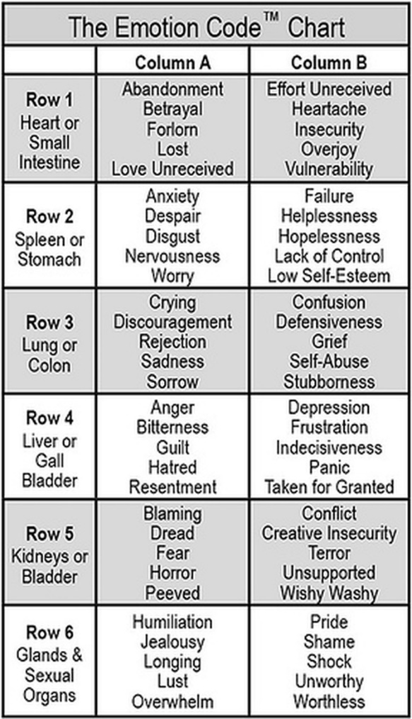
Other Modalities – Most of the trainings I have done. http://sheridanripley.com/appointments/curious-about-energy-work/
Spins – multiple emotions, 1 following another and they loop. Find and release and then Replace with Positive Emotions
Chakras - http://sheridanripley.com/abcde-of-chakras/
Root, sacral, solar plexus, heart, throat, third eye, crown
Aligned, balanced, connected, direction, energy
If there is fear, 90% of the time their root chakra going down is not spinning at the right speed.
“I ask that Julie’s root chakra spin at the ideal speed.”
Anahata Codes (I used this in one of the sample sessions) www.anahatacodes.com

So, so much more you can do with energy work.
From morning sickness
to healing from birth trauma.
Already have some experience with Energy Work and want more? http://sheridanripley.com/classes/energy-work/pre-birth-and-birth/ A higher level energy work class. Going deeper into birth work. For someone with experience doing energy work.

Discounted Session with Sheridan
Coupon Code – birth (for $20 off your first session)
http://sheridanripley.com/appointments/schedule-your-appointment/
My basic script for pre-birth/birth clearing.
“Clear this from every cell of your body, heart, mind and soul. Your enteric nervous system, brain stem and (_____ any other specific part).”
IMPORTANT questions as you finish up a session
• Are there any objections to what we cleared?
• Is this a good stopping point?

If you feel this class benefitted you, please share it with your fellow birth workers, by directing them to my site!
http://sheridanripley.com/classes/energy-work/birth-workers/

